Following diagrams show Classifies parameters used. This step is after exporting excel file of features in Classifier Learner App.

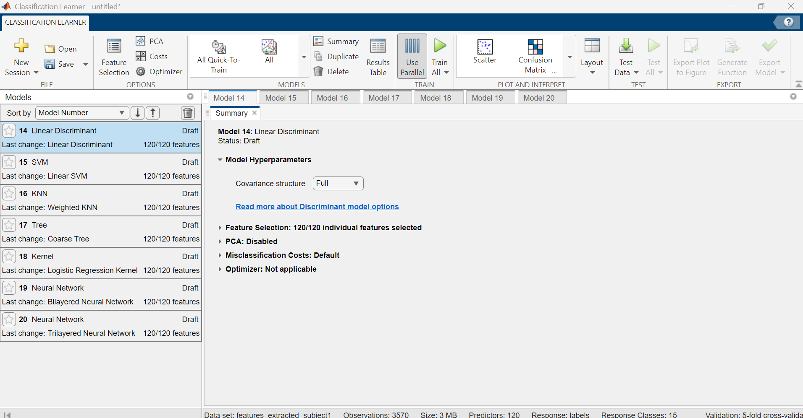
Chosen Parameters:
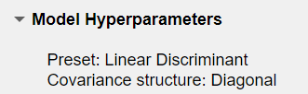
-------------------------------------------------------------------------------------------------------------------------------

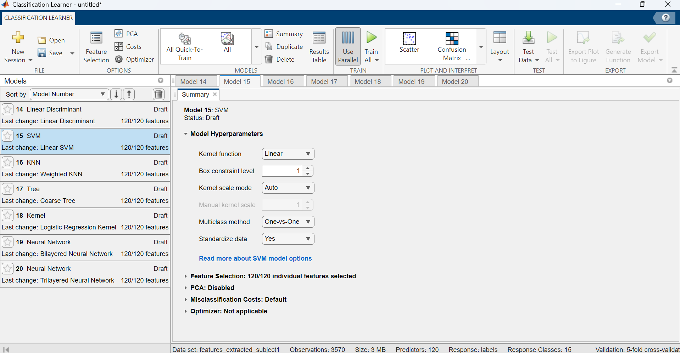
Chosen Parameters:
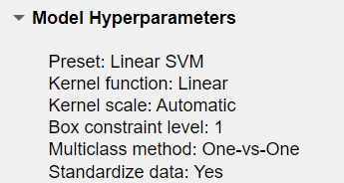
-------------------------------------------------------------------------------------------------------------------------------

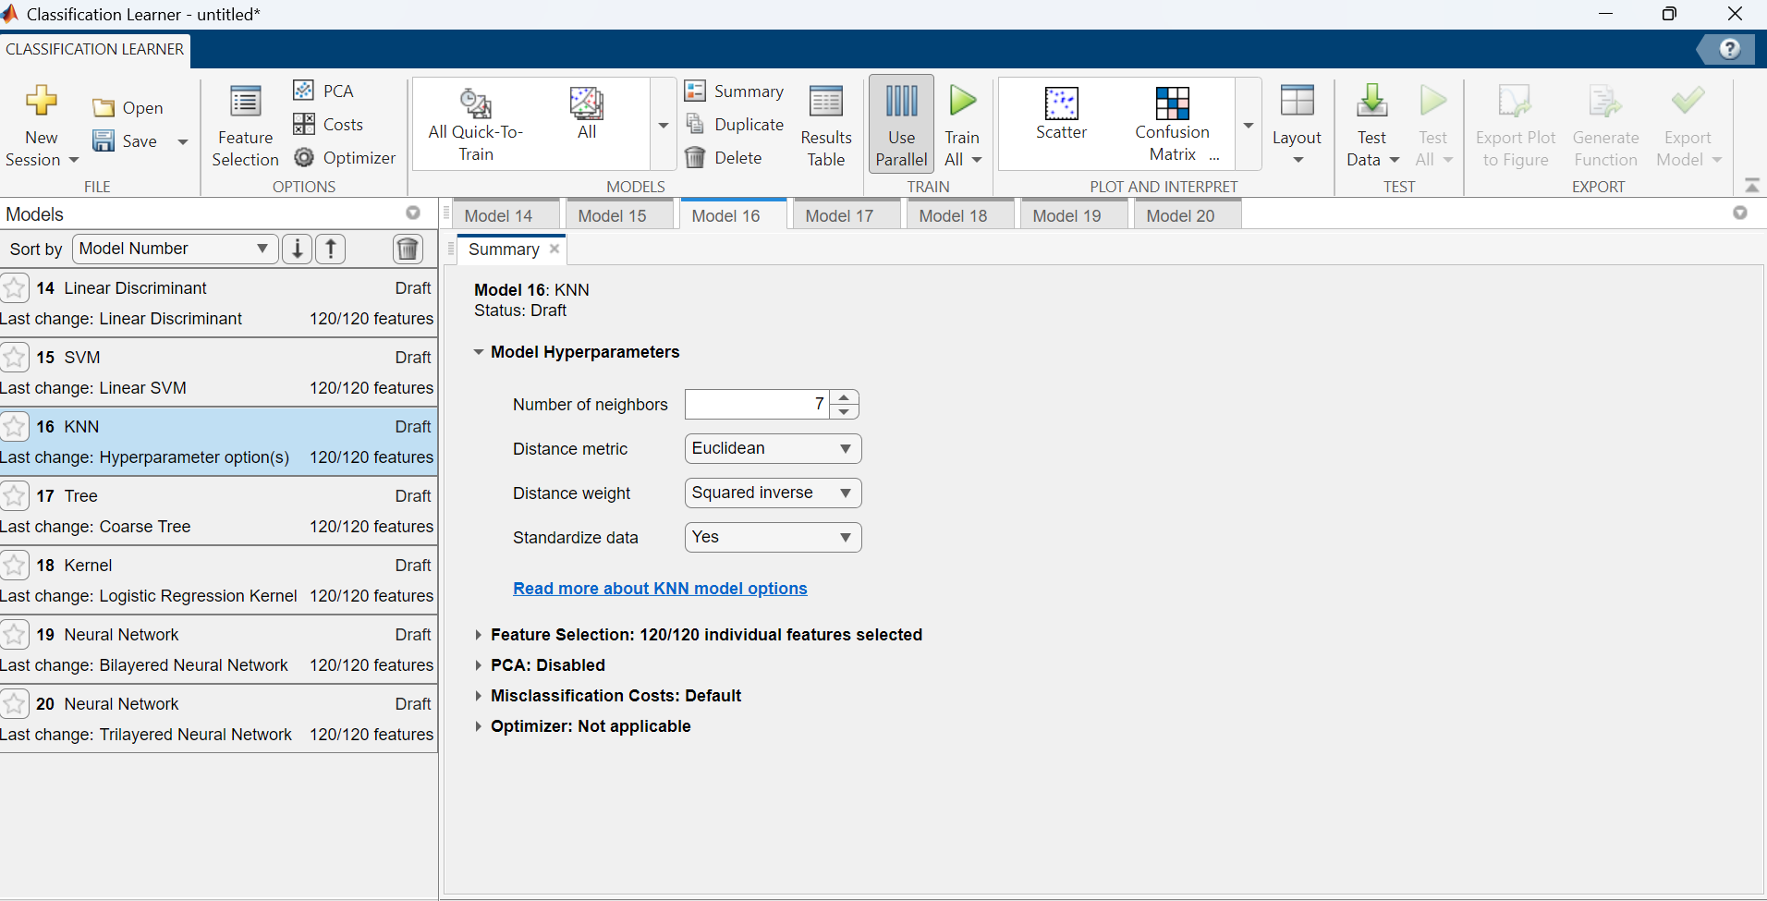
-------------------------------------------------------------------------------------------------------------------------------

Chosen Parameters:
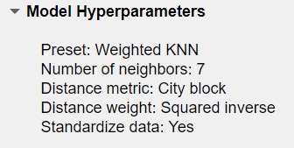
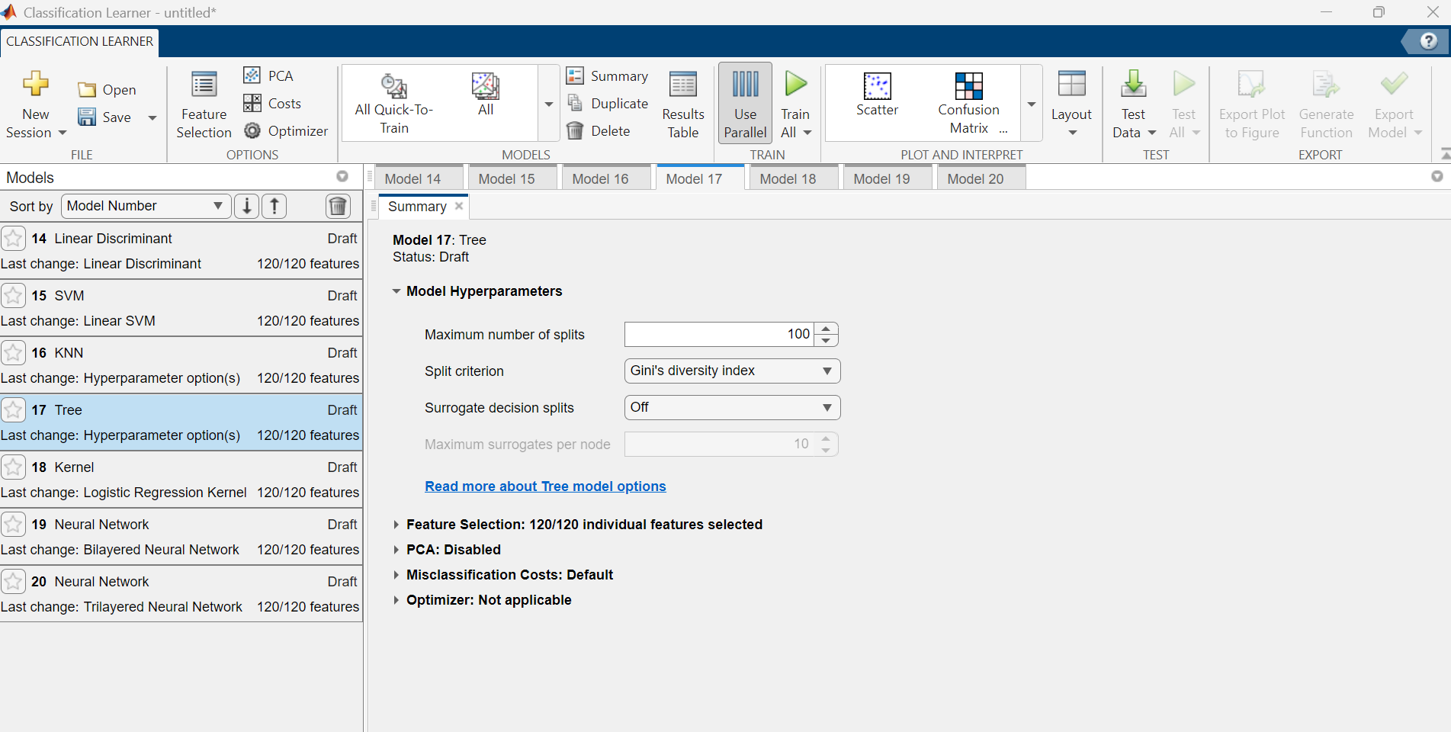

Chosen Parameters:
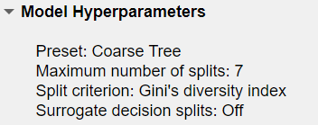
-------------------------------------------------------------------------------------------------------------------------------

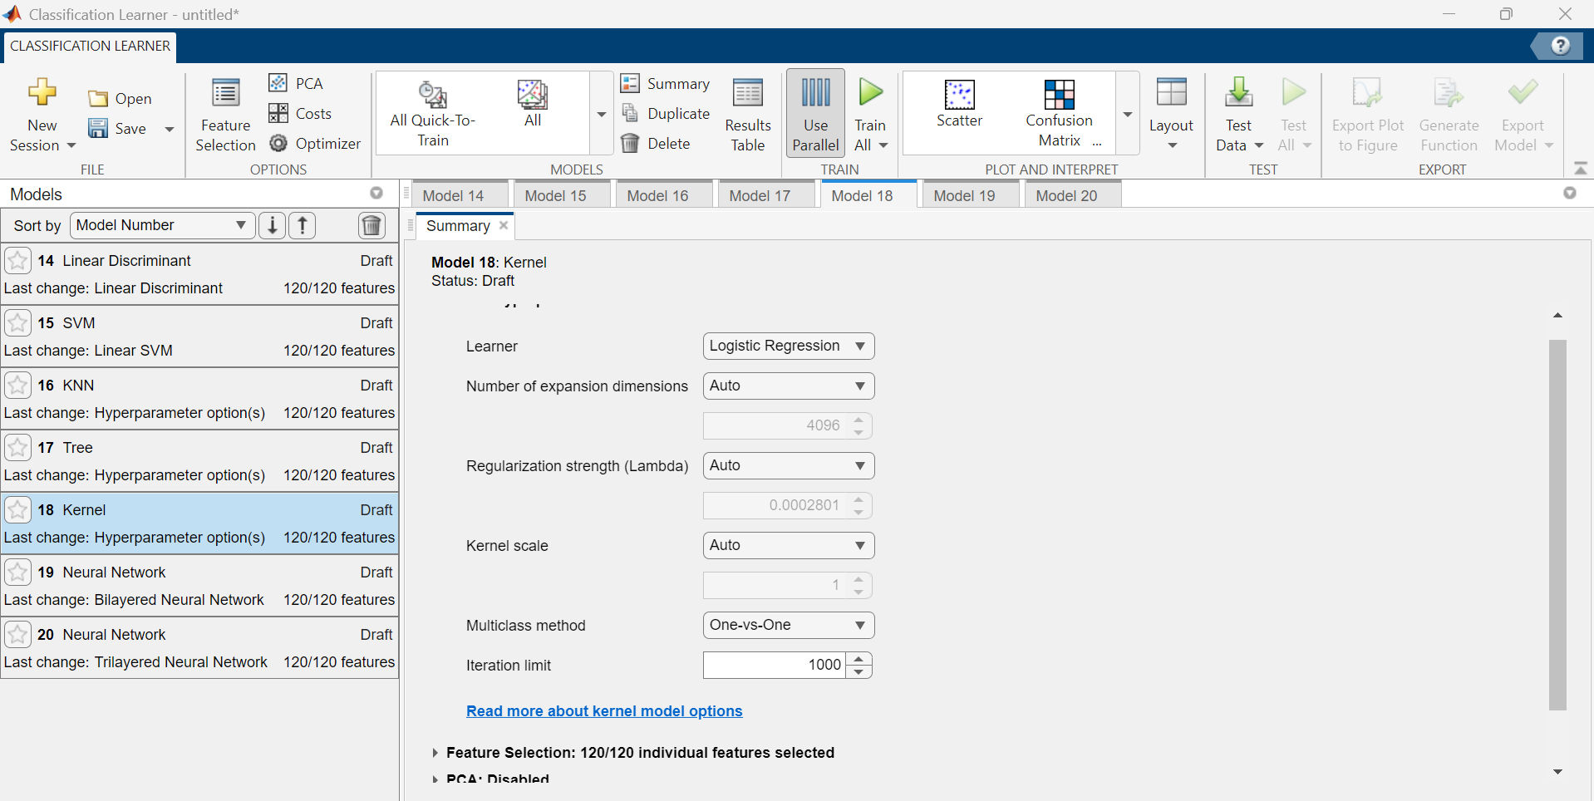

Chosen Parameters:
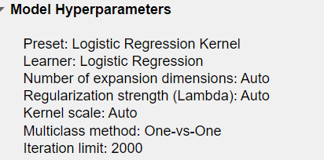
-------------------------------------------------------------------------------------------------------------------------------

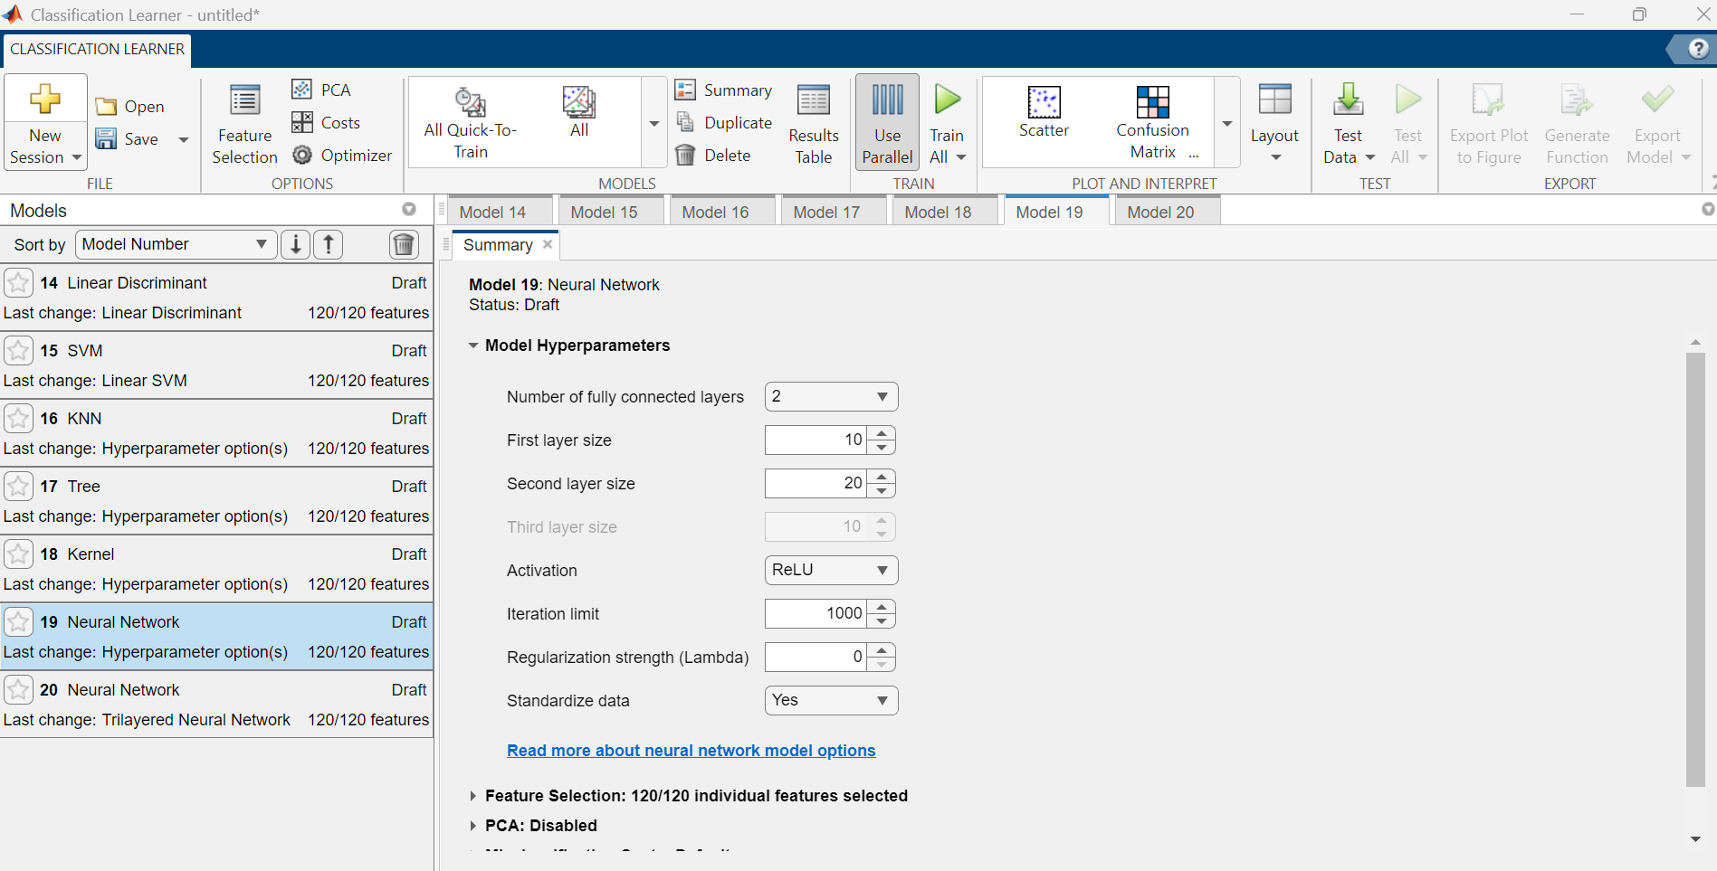

Chosen Parameters:
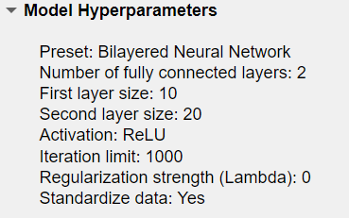
-------------------------------------------------------------------------------------------------------------------------------

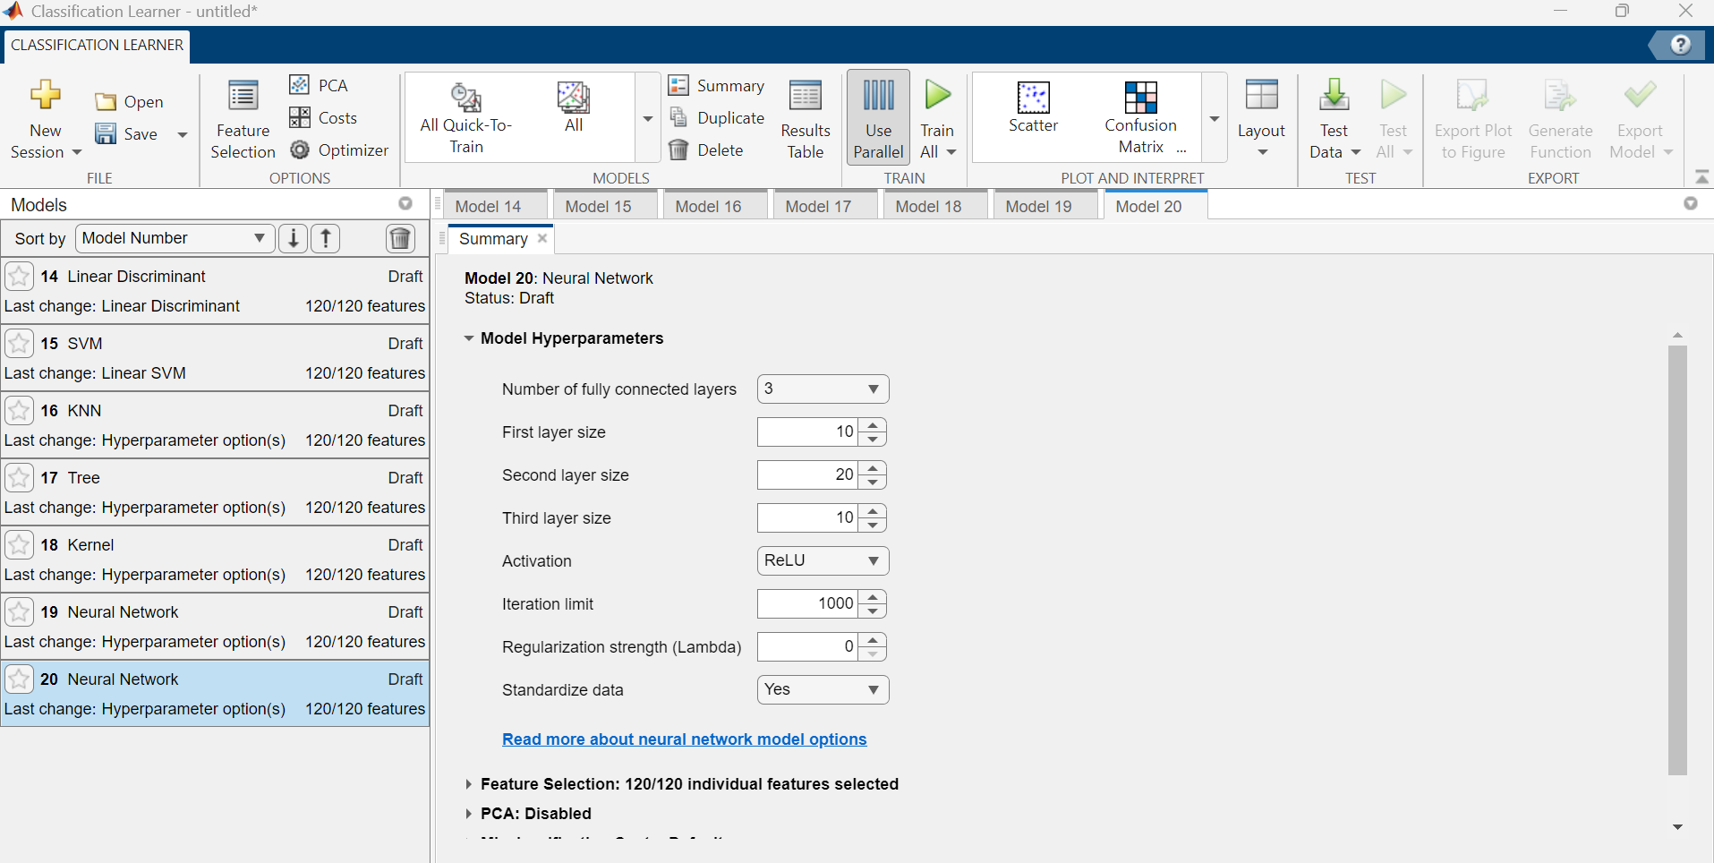

Chosen Parameters:



